Career Education/Club 360
Students will be able to describe the changing workplace and its implications for career decision-making and lifelong learning.

Standards
Per Section 1003.4156, Florida Statutes (F.S.),
C.E.P.C.S. 1.0 Describe the influences that societal, economic, and technological changes have on employment trends and future training.
C.E.P.C.S. 2.0 Develop skills to locate, evaluate, and interpret career information..
C.E.P.C.S.. 5.0 Understand the relationship between educational achievement and career choices/postsecondary options.
Instructional Practices
Lesson Plan: Understanding the Workplace
Topic: Local Jobs and Businesses and Their Contribution to the Community
Length: Two class periods
Objective:
Students will describe the influences on Job trends. Evaluate and interpret career information, determine employment trends and future training they may need. Develop skills to locate, evaluate, and interpret career information and understand the education achievement to achieve their career choice.
Materials: Internet-enabled computing devices, envelope, paper, pencil, Chart.
Description of Activity:
- View Introduction https://www.club360bay.org/career-lesson.html Write Personal note include
  - Name
  - Things you enjoy
  - What would
- Discuss with students some of the different types of businesses that operate locally.
- Students to View Jobs posted on https://www.club360bay.org/career-lesson.html
- Student will complete survey handout for 6-8 videos
- Student will share with the class one Job observed in the Video’s
- Name, profession, position/job title
- What education do you need for your career?
- Did you know your career choice when you graduated high school?
- What do you like most about your career?
- What do you like least about your career?
- What are two things you are most passionate about?
- Why did they choose their career?
- Who influenced you in your career?
- What advice would you give a student to help them find their passion and career?
- Include in the discussion the contribution the business makes to the local economy and to the people that live there.
- Discuss what the community would be like without the businesses discussed. For instance, if certain products or services were not available locally, people would drive to another city or order from a catalog or the Internet. How does this affect the economy in your community?
Evaluation:
Students will be able to describe three-five businesses in the community and how they contribute to the economy and society by completing chart.

Peel or ICE Paragraph answering following questions
1. Discuss the Jobs you might want to pursue, what class might help you in High School might help you.

2. Discuss what the community would be like without the businesses discussed. For instance, if certain products or services were not available locally, people would drive to another city or order from a catalog or the Internet. How does this affect the economy in your community?
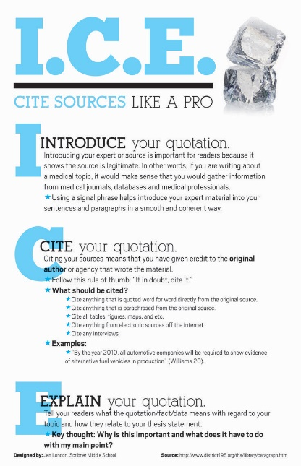
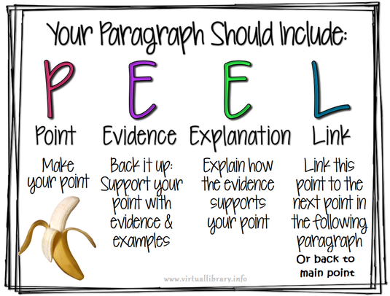

OR

Club 360 “Women Giving Back Full Circle”
The purpose of the organization is to provide the opportunity for women leaders in our community to give back full circle. This includes engaging girls to learn about future opportunities and career choices prior to graduating High School and providing scholarship opportunities for vocational and college degrees.
https://www.club360bay.org/

